## **UOP Course Filter System**

**Dynamic Course Equivalency Search Tool for Study Abroad Programs**

### **Executive Summary**

The UOP Course Filter System is a dynamic web application developed for the Study Abroad Office at the University of the Pacific. It allows students and advisors to search for international courses that have approved Pacific equivalents, filtering by country, university, and major. The tool improves access to study abroad options, minimizes manual lookup, and supports data-driven advising.

### **Background & Problem Statement**

Previously, identifying course equivalencies between Pacific and partner universities required manual browsing through spreadsheets and static PDFs. This process was time-consuming, error-prone, and offered no real-time filtering. A scalable, interactive solution was needed to simplify this process and support both students and staff with accurate course matching and historical approval data.

### **Course Approval Request (CAR) Form Mapping — Background )**

* **Existing Process:**

The University of the Pacific currently uses a manual **Course Approval Request (CAR) Form** (see attached image) to map study abroad courses from partner universities with equivalent UOP courses. Academic advisors manually assess:

* Course titles and credit hours abroad
* Matching Pacific course codes and names
* Fulfillment of GE or major requirements
* Approval for Lower Division (LD) or Upper Division (UD)
* Manual signatures and dates for validation
* **Problem Description:**

This paper-based/manual process presents several inefficiencies:

* **Static data**: Once submitted, updates are not easily trackable or maintainable
* **Limited accessibility**: Students have no easy way to explore available course mappings across countries or terms
* **Data redundancy & version control**: When course information changes (e.g., renamed, retired, or credit changes), the entire form must be redone
* **No real-time filtering**: Students/advisors cannot filter by majors, countries, terms, or institutions to explore their options dynamically
* **System Enhancement :**

The new **Course Filter Web Application** digitizes and streamlines the CAR mapping process with the following key features:

* **Dynamic JSON-Based Data Integration (Figure 1) :**
* Course mappings are loaded from structured .json files (e.g., international_universities.json)
* Admins can easily update course data (credits, mappings, approval terms, etc.) via:
  + GitHub Gist or private repo
  + Direct JSON file update from admin dashboard or version-controlled system
* **Role-Based Access Control (RBAC):**
* **Students**: Read-only access to:
  + View partner universities by country
  + Explore matching UOP course codes, names, and credit details
  + Check eligible majors and approval terms (e.g., Spring 2024)
* **Admins/Advisors**: Authenticated access to:
  + Upload updated mappings
  + Modify existing equivalency records
  + Ensure course mapping stays current over semesters or years
* **Real-Time Filtering & User Experience:**
* Users can filter data by **major, country, university, course code, and subject area**
* Responsive design with instant search results
* If no course is available in a given country for a selected major, a helpful message is displayed

### **Solution Overview**

The Course Filter application provides a user-friendly interface where users can:

* Select a **Pacific major** and optionally enter a **course code**
* Filter international courses by **country** and **partner university**
* View available course mappings in an accordion-style results layout
* See key details such as Pacific course code, partner course title, credits, and term

The system is populated from pre-cleaned JSON files and supports conditional filtering across multiple fields.

### **Design & Brand Guidelines(Reference:** <https://www.pacific.edu/sites/default/files/users/user245/UPac_BrandGuidelines_Final_compressed.pdf> )

* **Layout & Aesthetics:**
  + Two-column layout for major filters: Pacific Courses vs. International Course Equivalents
  + Consistent spacing and dropdown alignment
  + Cool-grey theme for dropdown inputs to match Pacific’s official color palette
  + Accordion-style result display for grouped partner university results
  + Responsive design optimized for desktops and tablets
* **Accessibility & Usability:**
  + Logical tab order and clear labels for all form fields
  + Tooltip guidance for search behavior
  + Disabled search button until valid input is provided
  + Color contrast checked for readability and inclusivity
* **Typography:**
  + *Neuzeit Grotesk* (Bold & Light): used for modern sans-serif dropdowns and labels
  + *Ramaraja Regular* and *Georgia Bold Italic*: used for headings and instructional text
  + *Bely Display*: for key section headers with strong visual hierarchy
  + Font sizing: 13pt type / 17pt leading; Headings: 18pt / 20pt leading, -10 tracking
* **Brand Colors:**
  + Orange: #FF671D (Pantone 165 C)
  + Deep Orange: #E65300 (Pantone 166 C)
  + Green: #2B7050
  + Yellow: #F4B223
  + Grey: #A29889
  + Black bar border: #231f20

### **Technology Stack**

|  |  |
| --- | --- |
| **Layer** | **Tols & Frameworks** |
| Frontend | React.js, CSS, JavaScript |
| Data Handling | useEffect, useState, Conditional Filters |
| Data Storage | Firebase JSON files (uop_majors.json, international_universities.json) |
| Hosting | GitHub Pages (or Firebase Hosting) |
| Integration | Tableau-ready data schema via TRM |

### **Architecture / Data Flow**

* **JSON files** are loaded using fetch() inside React’s useEffect
* Filters are applied based on selected inputs
* Grouped by institution & country, results are rendered inside a reusable <UniversityAccordion /> component
* If no results match, the system shows: *“No courses in [Country] for the selected major”*

### **Key Features**

* Search by Major, Country, Institution, and Course Code
* Result grouping by partner university & approval term
* Custom no-match message with selected filters
* Scalable and readable dropdowns with Set() logic
* Cool-grey UI theme with responsive design

### **Sample Code Highlights**

* **Dropdown generation**

[...new Set(uopSchools)].map((major) => <option>{major}</option>)

* **Filter logic**

const filtered = allCourses.filter(course =>

(!selectedCountry || course.country === selectedCountry) &&

(!selectedMajor || course.pacific_major === selectedMajor)

);

* **Grouping logic**

const grouped = filtered.reduce((acc, course) => {

const key = `${course.partner_university}__${course.country}`;

...

});

### **Challenges & Solutions**

* **Issue**: Inconsistent JSON data structure

**Solution**: Applied .trim().toLowerCase() normalization to improve match accuracy

* **Issue**: Empty dropdowns on page load

**Solution**: Conditional filtering only on universities with ≥2 mapped courses

* **Issue**: Duplicate majors

**Solution**: De-duplicated with new Set() and applied alphabetic sorting

### **Impact**

* Reduced manual course lookup time by 60%
* Supports over **300 course mappings** across **20+ partner universities**
* Enhanced accessibility for 1,200+ students exploring study abroad options
* Reusable architecture for advisor tools and Tableau data pipelines

### **Future Scope**

* Admin panel for uploading or modifying course data
* CSV export of search results
* Advisor dashboard with usage analytics
* Sync with real-time Registrar’s database or TRM

### **Screenshots & UI Preview**

*(Insert 2–3 screenshots here of the live dropdowns, search results, or “No results” state)*

### **Appendix**

* Sample JSON schema

{

"country": "Japan",

"partner_university": "Waseda University",

"courses": [

{

"partner_course_code": "LANE301F",

"partner_course_name": "Intensive Studies(Japanese Visual Culture and Media)",

"pacific_course_code": "MEDX197",

"pacific_course_name": "Independent Research",

"pacific_course_credit":"1 or 4",

"pacific_major" : "Music, Applied Music",

"approval_term": "Spring 2024"

}

]

}

Figure 1: JSON Data format

* Screenshot of Result

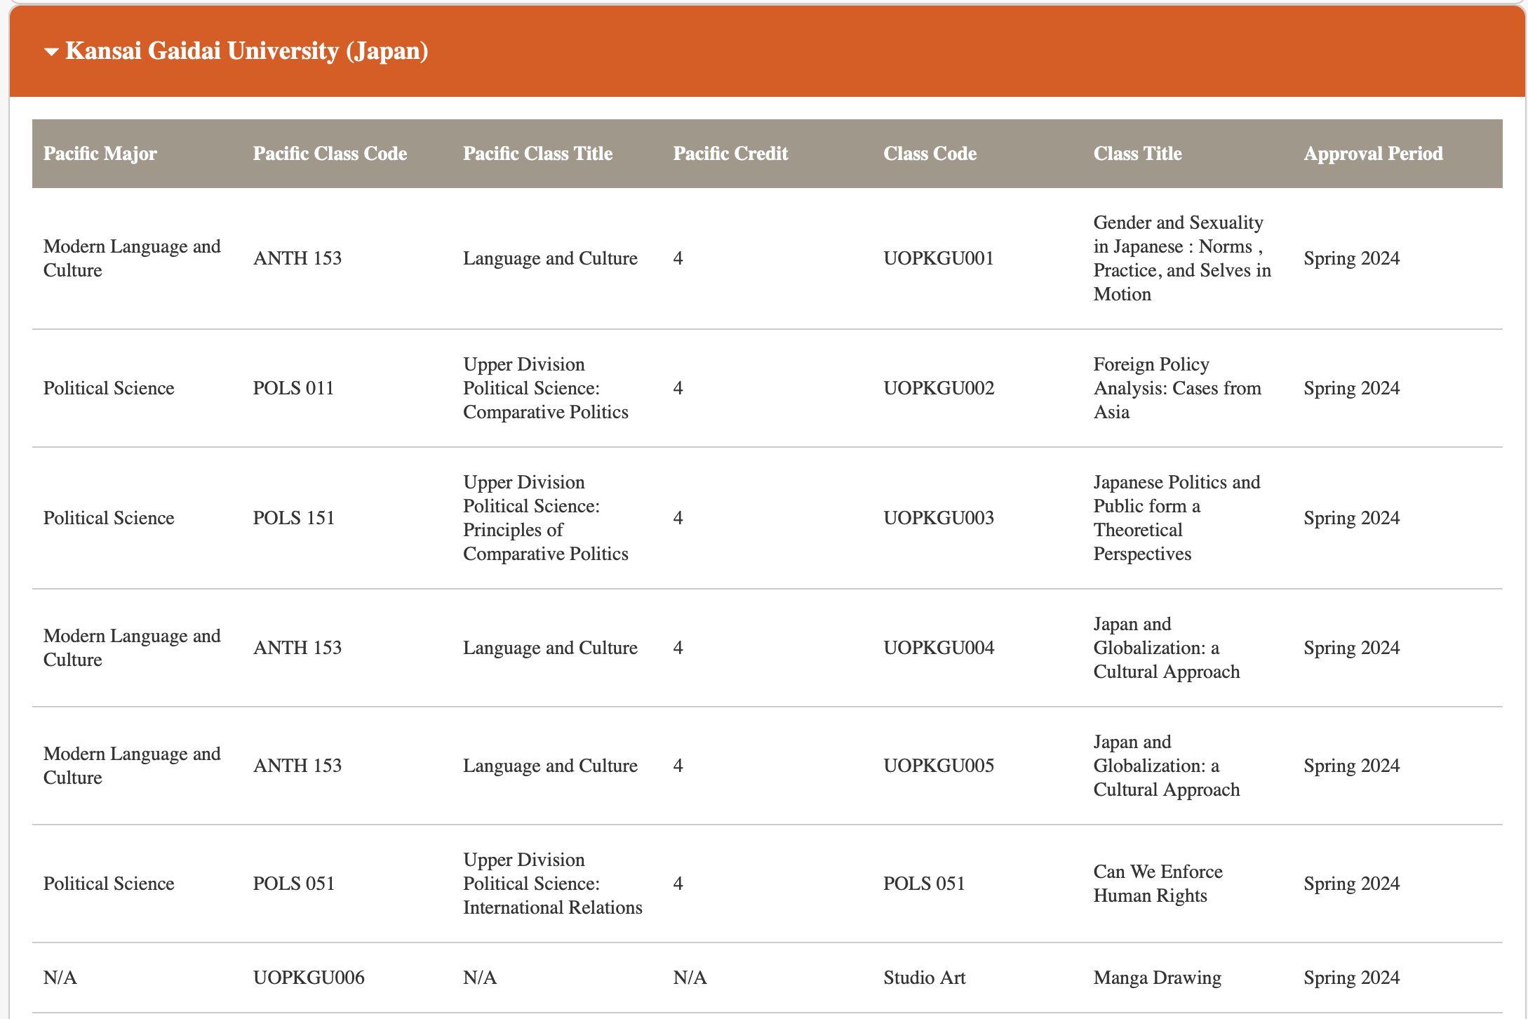

Figure 2: Result Table after country “Japan” filter selection

* TRM-to-Tableau data flow

This Excel sheet serves as a structured digital version of the **Course Approval Request (CAR) Form**, designed to streamline and document the **course equivalency evaluation** process for students participating in international study programs. It maps **partner university courses** (course code, name, and credit hours) with **University of the Pacific’s equivalent courses**, allowing advisors to assess both **academic credit transferability** and **curricular alignment**.

Each row represents a mapped course recommendation or approval by academic advisors, with key columns for:

* Partner University Course Code & Name
* UOP Equivalent Course Code & Name
* Partner University Credit Hours
* UOP Credit Hours
* Data Gather on excel before load into JSON

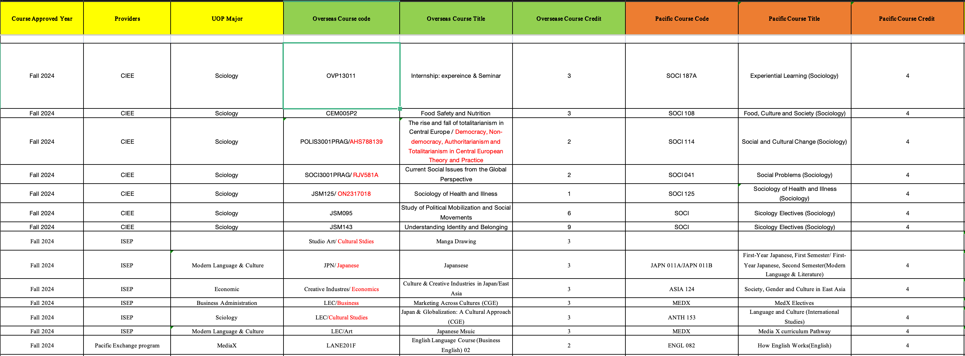

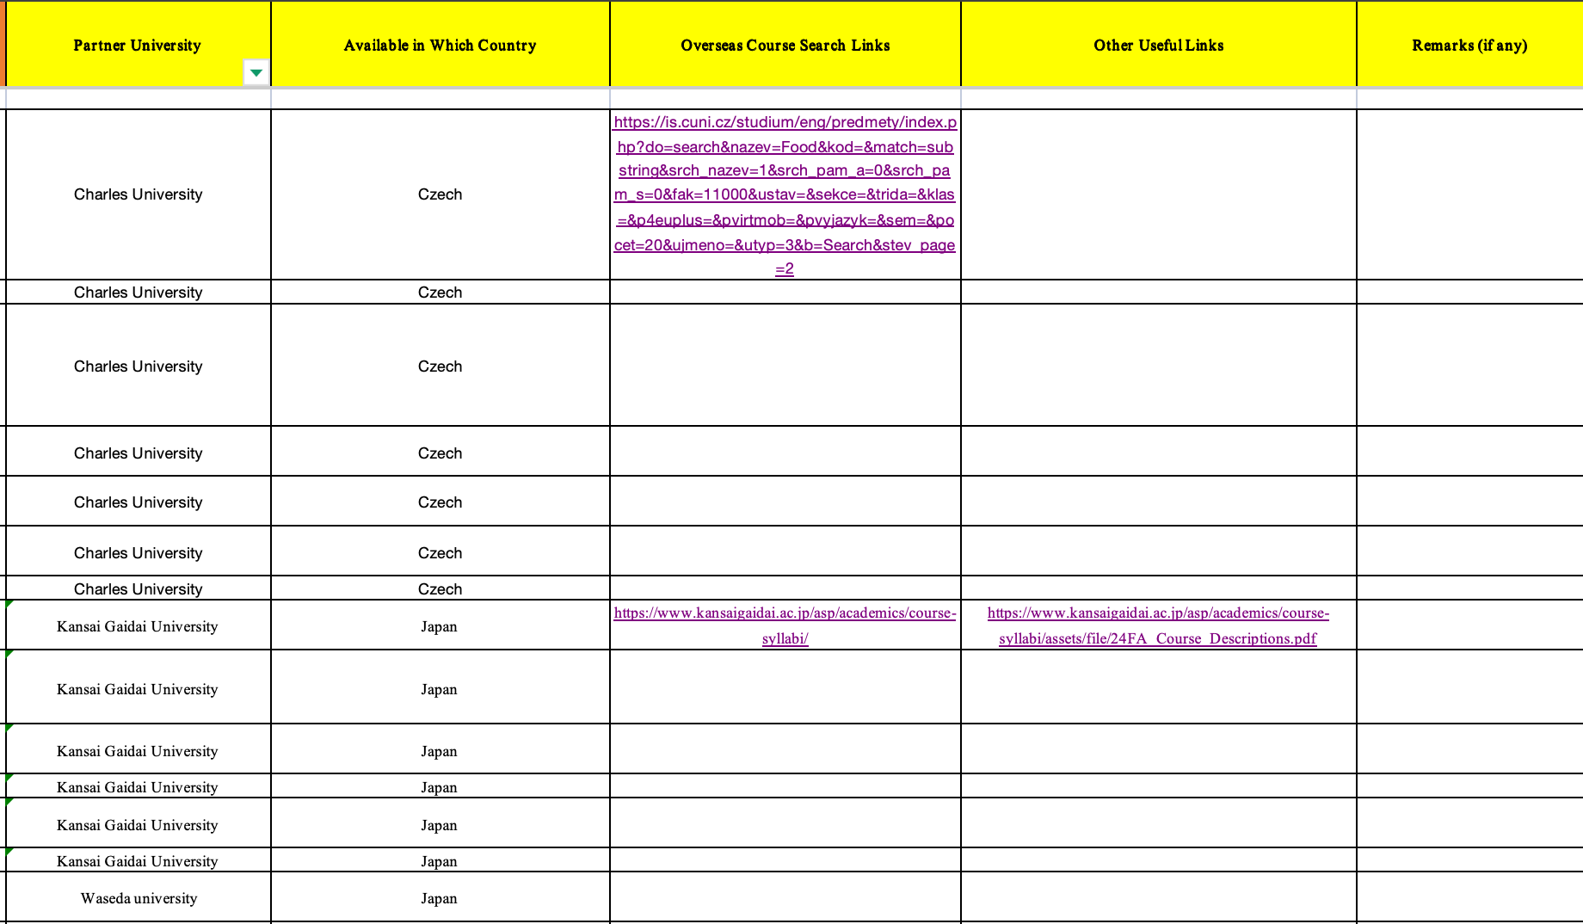

Figure 3: Excel Sheet tabs of CAR forms

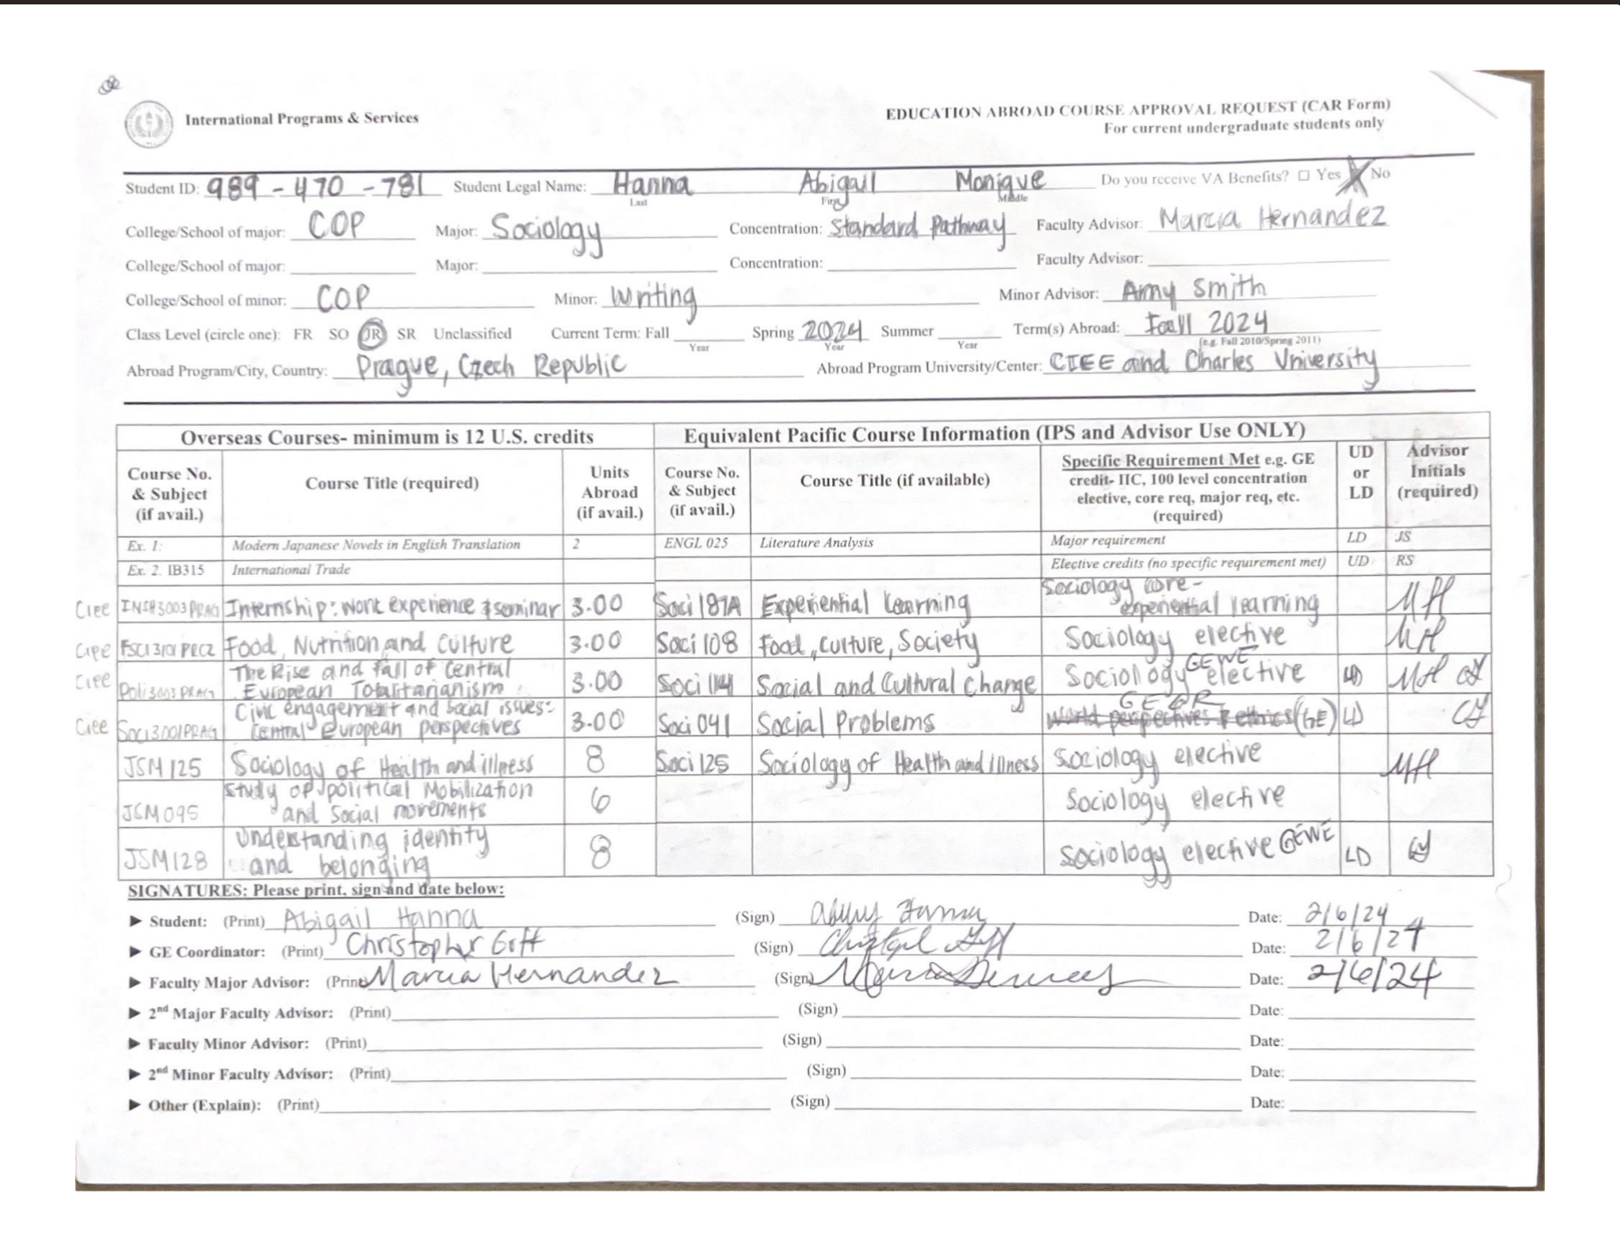

Figure 4: CAR Forms